 T-CLOCK Inspection 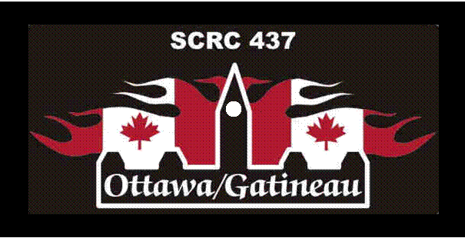

Item | What to check | What to look for | Check-off
T - Tires and Wheels |  |  | Front | Rear
Tires | Condition | Tread depth, wear, weathering, evenly seated, bulges, imbedded objects | F | R
Tires | Air pressure | Check when cold, adjust to load/speed | F | R
Wheels | Spokes | Bent, broken, missing, tension, check at top of wheel: "ring"=ok--"thud"= loose spoke | F | R
Wheels | Cast | Cracks, dents | F | R
Wheels | Rims | Out of round/true - 5mm, spin wheel, index against stationary pointer | F | R
Wheels | Bearings | Grab top and bottom of tire and flex: no free play (click) between hub and axle, no growl when spinning | F | R
Wheels | Seals | Cracked, cut, or torn, excessive grease on outside, reddish-brown around outside | F | R
C - Controls
Levers | Condition | Broken, bent, cracked, mounts tight, ball ends on handlebar lever | F | R
Levers | Pivots | Lubricated
Cables | Condition | Fraying, kinks, lubrication: ends and length
Cables | Routing | No interference or pulling at steering head, suspension, no sharp angles, wire looms on place.
Hoses | Condition | Cuts, cracks, leaks, bulges, chafing, deterioration
Hoses | Routing | No interference or pulling at steering head, suspension, no sharp angles, wire looms on place.
Throttle | Operation | Moves freely, snaps closed, no revving
L - Lights and Electrical
Battery | Condition | Terminals, clean and tight, electrolyte level, held down securely
Battery | Vent tube | Not kinked, routed properly, not plugged
Lenses | Condition | Cracked, broken, securely mounted, excessive condensation
Reflectors | Condition | Cracked, broken, securely mounted
Wiring | Condition | Fraying, chafing, insulation
Wiring | Routing | Pinched, interference/pulling at steering head or suspension, wire looms and ties in place
Headlamp | Condition | Cracks, reflector, mounting and adjustment system
Headlamp | Aim | Height and right/left
Item | What to check | What to look for | Check-off
O - Oil and Fluids
Levels | Engine oil | Check warm as per your Owner’s manual
Levels | Hypoid gear oil | Transmission, rear driver, shaft
Levels | Hydraulic Fluid | Brakes, clutch, reservoir or sight glass
Levels | Coolant | Reservoir and/or coolant recovery tank - cool only
Levels | Fuel | Tank or gauge
Leaks | Engine oil | Gaskets, housings, seals
Leaks | Hypoid gear oil | Gaskets, seals and breathers
Leaks | Hydraulic Fluid | Hoses, master cylinders, callipers
Leaks | Coolant | Radiator, hoses, tanks, fittings, pipes
Leaks | Fuel | Lines, fuel caps, carbs
C - Chassis
Frame | Condition | Cracks at gussets, accessory mounts, look for paint lifting
Frame | Steering-head bearing | No detent or tight spots through full travel, raise front wheel, check for play by pulling/pushing forks
Frame | Swing arm bushings / bearings | Raise rear wheel, check for play by pulling/pushing swing arm
Suspension | Forks | Smooth travel, equal air pressure/damping anti-drive settings
Suspension | Shock(s) | Smooth travel, equal pre-load/air pressure/damping settings, linkage moves freely and is lubricated
Chain or belt | Tension | Check at tightest point
Chain or belt | Lubrication | Side plates when hot-DO NOT lubricate belts
Chain or belt | Sprockets | Teeth not hooked, securely mounted
Fasteners | Threaded | Tight, missing bolts, nuts
Fasteners | Clips | Broken, missing
Fasteners | Cotter pins | Broken, missing
K - Kickstand
Side-stand | Condition | Cracks, bent, (safety cut-out switch or pad if equipped)
Side-stand | Retention | Springs in place, tension to hold position

