Flags
1. Nothing above the Canadian Flag. It should be the highest patch, normally above the heart (left side) or centered at the back (top of vest).

2. Other flags, i.e. Provincial, territorial or others, should be below the CA Flag. If more than one is used, they should be in order of precedence.

3. Any other country flags should be at the same level as the CA Flag, with the CA Flag taking precedence on others. So when looking at the flags, the CA Flag is on the Left (its own right).

Club Patches

1. Road Handle/Nickname: Should be on the left side (higher portion of the vest, below the CA Flag, or any other Provincial/Territorial, etc Flags).

2. Club position (Officer, Road Capt, etc, if any): Under the Road Handle/Nickname.

3. SCRC Small patch: On the opposite side of the vest from Road Handle/Nickname.
Miscellaneous patches
Any other patches, like In, Memoriam, rally, sayings, etc., are at the discretion of the member. See para 6 and 7 below for further explanations.

The SCRC Patch (Winged Eagle).

When it comes to the SCRC patches, they are trademarked and cannot be copied. Our Constitution speaks about the patch itself.

1. The "Patch", as worn on the vest or jacket shall consist of the Winged Eagle worn on the upper half of the back on a vest or jacket as the cut of the vest may allow.

2. The SCRC Club Patch is not and should not be referred to as "Colors". No three-piece patches are permitted in the SCRC. Be careful when you add patches to the back of the vest that it does not look like a “3-Piece”

3. No Member of the SCRC shall ever add the letters MC or wear the designation 1% on their vest, jacket or any other article of clothing while representing the SCRC.

4. No M/C or 1% Support patches or any kind of MC support insignias, such as hats, T-shirts, stickers on helmets or bikes, or representations of any kind, will be displayed by members of the Southern Cruisers while wearing the SCRC patch, participating in Southern Cruisers events, or representing the Southern Cruisers in any way.

5. No Rockers/Chapter Location Bars - "CLBs" that identify a City, Province, Territory, Region or Country, or anything giving the appearance of a rocker will be worn with the SCRC wings on the back of the vest or jacket. This is a big No-No, as dominant clubs might take offence. This one HAS to be followed.

6. The Southern Cruisers is a neutral, family oriented, international riding club and cannot show preference to any one club over another. This would not include brand specific organizations such as HRCA, HOG, VROC & etc.) The patches associated with those clubs would be acceptable.

7. Other patches that present the Southern Cruisers in a bad light will also not be worn. Especially patches which are vulgar, racist, demeaning, etc. If there is any doubt, contact the Chapter’s Officers for clarification.
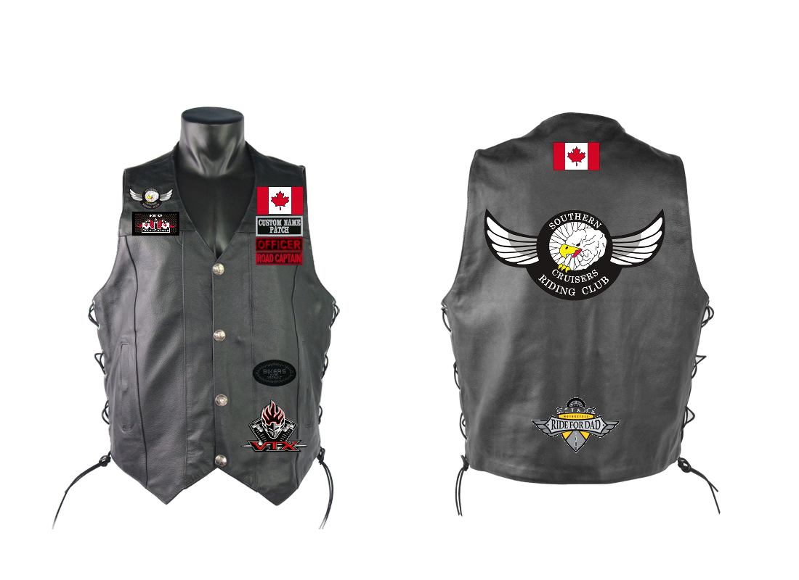
Brand specific organizations are allowed
Miscellaneous patches locations are at the discretion of the member
Canadian Flag can be replaced by a Provincial/Territorial flag, if the Canadian flag is worn on the back
Road Handle
Chapter Patch
SCRC Winged Eagle: Upper half of the back on a vest or jacket
SCRC Patch:
Winged Eagle
Ripping Eagle, or
Flaming SCRC
Officer’s Position
Club Appointment
Canadian Flag can be on the Front top left or top centre on the Back
SCRC Chapter 437 Patch Placements

